TOS PRESET |  |  | Spike Color: BLUE
Stage Right |  | Onstage | Stage Left
PRELUDE  2 Small Canvas Bags  1 Large Canvas Bag  2 Sea Chests  ACT 1, SCENE 2  1 Honing Stone  1 Harpoon (no rope)  2 Lances  Grog Jug  ACT 1, SCENE 5  6 Scrimshaw Tools  6 Whale Teeth  Spanish Sailor Knife  Netting  Corncob Pipe  2 Wooden Pipes  2 Oars  Harpoon Rope | ACT 1, SCENE 6B  Table  Stool  1 Sea Chart  Log book  Quill and Inkwell  1 Rifle  Compass  ACT 2, SCENE 1  1 Rag  1 Tall Ladders  1 Short Ladder | QUEEQUEG CUBBY  Long Rope w/ Carabineer  Tomahawk Pipe w/  Powder  1 Honing Stone  Matches  Idol  OTHER CUBBY’s  Small Brown Bag  Small Blue Bag | PRELUDE  1 Large Blue Striped Bag  1 Large Canvas Bag  1 Small Brown Bag  1 Small Blue Bag  1 Small Tan Bag  Green Canvas Bag  ACT 1, SCENE 2  1 Honing Stone  2 Harpoons (no ropes)  1 Lance  1 Wooden Mallet  Stubb’s Pipe  ACT 1, SCENE 3  Leather Spyglass  ACT 1, SCENE 4  Double Walking Stick  ACT 1, SCENE 5  No Tambour Tambourine  long White Pipe  Shell  2 Small Ropes  3 Scrimshaw Tools  2 Whale teeth  2 Oars  Harpoon Rope  Short Ladder  Blanket | ACT 1, SCENE 6  5 Bloody Rags  1 knife  2 Blubber Forks  2 Ladles  3 Mincing knives  8 Minced Blubber  13 Cubed Blubber  ACT 2, SCENE 1  2 Hammers  4 Ropes  2 Buckets  12 rags  4 Mops  1 Knife  1 Tall Ladders  1 Short Ladder  ACT 2, SCENE 2  Tambourine  ACT 2, SCENE 4  Hammer  Metal Spear  Wooden Spear handle  file  ACT 2, SCENE 5  Coffin (no lid)  ACT 2, SCENE 7  Ahab Rope w/ caribeener  ACT 2, EPILOGUE  Coffin Lid
 |  | Stage Left Blood Table
2 Minced Blubber Pieces
Tarp
1 Mincing knife
Blood Bottle

 | Mr. Honeywell’s Table (SR)
Walking Stick
Gold Spyglass
Doubloon
 |  | SL Whaleboat
 |  | 2 Oars

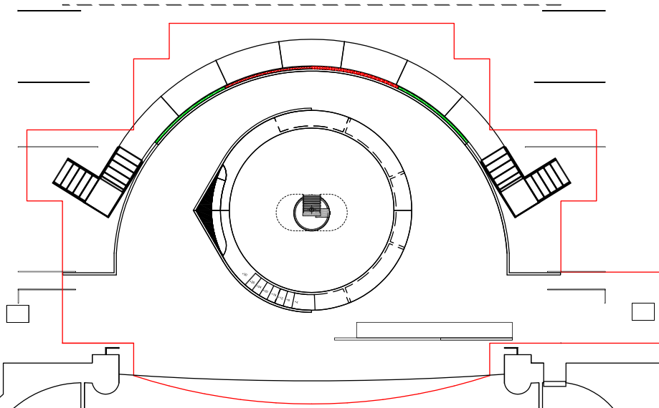
Blue Bag
Brown Bag
Queequegs’s Cubby

ACT I RUNNING (78:30)
Time | Where | What |  |  | Cue
7:00 | ONSTAGE | FIREWATCH | 1 MATCH LIT |  | Kelly
9:45 | SL 1 & SR 1 | CATCH | CANVAS BAGS (5) SR and (4) SL |  | Vicki & Nan
 | SL 1 | CATCH | GREEN CANVAS BAG from GREENHORN (J. Dennis)  TOMAHAWK PIPE & MATCH from QUEEQUEG (M. Ngqungwana) |  | Kelly
 | SR SL | TRACK |  | KNOT CANVAS BAG | JR
14:45 | SL | HANDOFF | WOODEN MALLET to CORO MAN (S. Tarbet) |  | Kelly
21:05 | SR | HANDOFF | GROG JUG to DANCER (J. Claudio) |  | Nan
24:30 | SR SL | TRACK | 1 LANCE |  | JR
 | SR & SL | ADD | HARPOON ROPES to HARPOONS |  | Nan
46:30 | SL | LOAD | BLOOD in MINCED BLUBBER
53:00 | SR | CATCH  HANDOFF | CORNCOB PIPE, KNIFE, ROPE from CORO MEN  (D. Wilkinson & M. Flint)  1 LANCE and 2 OARS |  | Nan
 | SL 1 | CATCH | Short Ladder (S.Finklestein) |  | Kelly & Vicki
 | SL 1 | CATCH | 2 CANVAS BAGS, Netting (P. Hill) & NON TAMBOUR TAMBOURINE (J. Habersham) |  | Kelly & Vicki
53:10 | SL Stairs | HANDOFF | 2 OARS to CORO MEN (Josh Stead & S.Finklestein)  LANCE to STUBB (C. IRVIN) |  | Kelly
53:20 | SR 1 | HANDOFF | LANCE to FLASK (J. Gaines) |  | Nan
55:10 | UL Stairs | CATCH & HOLD | HARPOON |  | Kelly
 | SR 1 |  |  |  | Nan
55:20 | Behind Window 1 # 2 | LOAD | 3 Pieces of BLUBBER |  | Vicki
55:30 | UL DOGHOLE SR | CATCH & TRACK | 2 OARS & 1 LANCE |  | JR
 | SL Stairs | AUTO FOLLOW | Help with Blubber Load
 | SR 1 | PREP | AHAB TABLE & STOOL |  | Nan
56:05 | SL 1 | PRESET | Bloody Blubber in Tarp with Mincing Knife, & Blood Bottle
57:00 | SL 1 | RECIEVE  HANDOFF | 1 HARPOON (JUAN CARLO)  2 LADLES (Juan- Carlo)  2 BLUBBER FORKS, 2 MINCING KNIVES (B. Akinboboye)  8 PIECES OF MINCED BLUBBER in TARP (Allen & Clifton) |  | Kelly & Vicki
58:00 | SL 1 | ASSIST | STARBUCK w/ BLOODY MINCED BLUBBER and TARP |  | Kelly
58:30 | SL Whale Boat | STRIKE | 1 Lance |  | Vicki & Kelly
62:45 | SR 1 | HANDOFF | Map to Ahab |  | Nan

Intermission Shift to Act II (20:00) |  |  |  | Time for Shift – 20:00
Immediate | Onstage | STRIKE | Blubber, Tarp, Ladles, Blubber forks & Mincing Knives |  | ALL
 |  | CLEAN& MOP | Disc & Deck
 |  | SET | Knife, 2 Tall Ladders, 2 Short Ladders, 2 Mop Buckets & 4 Mops, 11 Cleaning Cloths, 3 Hammers, 4 Ropes
After scenic shift complete | SR/SL | SET | Prop Tables
 | SL SR | TRACK | Leather Spy Glass |  | Vicki
 | Onstage SL |  | Lance & 2 Oars |  | Kelly
 | SR SL |  | Queequeg’s Harpoon |  | Jr
 | SL & SR | REMOVE | Harpoon Ropes from Harpoons |  | Kelly & Nan

ACT II PRESET |  | Spike Color: GREY
Stage Right | Onstage |  | Stage Left
ACT 2, SCENE 1  Leather Spyglass  1 Cleaning Cloth  ACT 2, SCENE 7  1 Harpoon  1 Lance  2 Oars  ACT 2, EPILOGUE  Ahab Double Cane | ACT 2, SCENE 1  2 Tall Ladders  2 Short Ladders  2 Mop Buckets  4 Mops  3 Hammers  11 Cleaning Rags  4 Ropes  Knife |  | ACT 2, SCENE 1  1 Cleaning Cloth  ACT 2, SCENE 2  Tambourine  ACT 2, SCENE 4  Sail  Hammer  Metal Spear  Wooden Spear handle  file  ACT 2, SCENE 5  Coffin (no lid)  ACT 2, SCENE 7  2 Harpoons  4 OARS  1 Lance  ACT 2, EPILOGUE  Coffin Lid
 | SL Whaleboat
2 Oars
Ahab Rope w/ carabiner

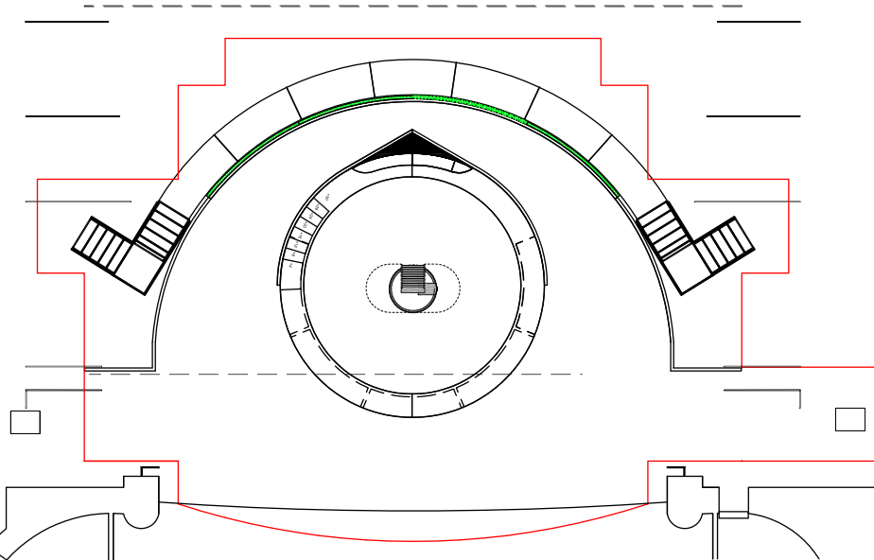
Short Ladder
Tall Ladder
Short Ladder
Tall Ladder
11 Rags & 3 Hammers
4 Mops & 2 Buckets
4 Ropes
Knife

ACT II RUNNING (62:30)
Time | Where | What |  | Cue
3:45 | SR1 | CATCH | 1 Ladder (DR) | Jr & Nan
8:30 | SL1 | CATCH | 1 Ladder (UL)
8:45 | SL 1 | CATCH | 4 Mops & 2 Buckets, Multiple Cleaning Cloths & Hammers | Kelly & Vicki
10:30 | SL1 | CATCH | 1 Ladder (DL) | Kelly
 | SR1 | CATCH | 1 Ladder (UR) & Cleaning Cloths | Nan & Jr
23:30 | SL1 | HANDOFF | SAIL to G. Medlock & D. Nicols | Vicki
 |  | HANDOFF | File, Hammer, Wooden Handle, Spear to D. Tuutau | JR
31:45 | SL1 | ASSIST | Dancers w/ Coffin w/ lid OFF | JR & Vicki
36:15 | SL1 | ASSIST | Dancers w/ Coffin | JR & Vicki
 | SL | ADD | Lid to Coffin | JR & Vicki
 | SL & SR | PRESET | Oars on Balcony | Vicki & Jr
52:00 | SR Stairs | HANDOFF | 1 Lance to FLASK | Nan & Jr
 | SL Stairs |  | 1 Lance to STUBB | Vicki
58:30 | ON DISC | PLACE | Coffin W/ Lid on | Kelly & Vicki
 | ONSTAGE in DISC CUBBY | STRIKE | AHAB Walking Stick | Kelly

